2. 6 Re c lamation Plan
2. 6. 1 Introduction
This Reclamation Plan has been re ared specifically for use at CargiU' s Cayuga Mine
Facihties atCar iU's Ca u aMine include bothsurface andsubsurfaceo erations The gygp
surface workings have been previouslyshown on the Surface MiningPlan Map(Plate 22- 1) a nd the Surfa ce Recla ma tio n Pla n Ma p (Pla te 26- 1) The planne d limits o f the undergroundworkings have also previously been shown on the Subsurface MiningPlan Map(Plate 23- 1)
'
Aconsequence ofundergroundminingatCargUls Cayuga mine is the slight, gradual
,
2. 6. 2 Subsidence
Whenever rock is removed from the underground, the ground surface subsides The amountofthesubsidenceandtherateatwhichsubsidenceoccursdependsuponthe amountofrockremoved, the area ofthe extraction, the depthofthe extraction, andthe deformationalcharacteristicsofthepiUarsandoverlyingrockSurfacesubsidenceoversalt minesis stronglytime- dependentbecausesubsidence accumulates fromthetime ofmining untUthe undergroundopenings ai' e completelyclosed Subsidence, atincreasinglyslower rates, maycontinuefor centuries
Because rock salt creeps, the rock surrounding the mine is continuously (hut usually very slowly)movingtowardandinto the mine openings The time requiredfor the creepto completely close the openings can be as great as thousands ofyears, depending upon extraction ratios, roomsize, pillar size, geologic setting, depthandthe time since mining ceased
The ultimate volume ofthe depression createdon the groundsurface fromsubsidence will heaboutthesame(or smaller)thanthevolumeofmaterialremovedfromthe underground The amountofsubsidenceofthegroundsurfacethatoccursover asaltminecanhe calculatedbasedu pon a few gen eralprinciples These include:
1 Thesaltstrataaroundanundergroundopeningwillcreeptowardandintothe openinguntiltheopeningiscompletelyclosed
CARGILL CAYUGA MINE PAGE 77 Min ded La n d Use Plan - 12/22/00 #98189
pp
subsidenceoftheoverlyingsurfacetopography
When minin andassociatedactivities cease at Car iU's Ca u a Mine bothsurface and
The largestamountofsubsidence occurs over areas withthewidestspans The maximumamountofsubsidence thatcan occur is always less than the heightof m i n i n g (i e t h e t h i c k n e s s o f t h e m i n e d s e a m )
3 Apointon the groundsurface subsides because ofboththe miningdirectly beneaththatpointandanyminingthatoccursin the generalarea
4 The area above the mine with measurable surface subsidence will be larger than theareaoutlinedbythemineworkings Adistanceequaltothedepthofthe mineisareasonableestimateofthelateralextentofsurfacesubsidencebeyond themineperimeter
5 The ultimate volume ofthe depression on the groundsurface fromsubsidence willneverexceedthevolumeofmaterialremovedfromtheunderground
Cargillhas modeledthe anticipatedsubsidence attributable to the excavation ofthe Level No 6Saltalongthe shoresofCayuga Lake
2. 6. 3 Reclamation ofSubsurface Featur es
T h e N e w Y" o r k S t a t e M i n e d L a n d R e c l a m a t i o n L a w (M L R L ) d o e s n o t r e g u l a t e o r r e q u i r e t h e reclamation ofthe subsurface workings ofundergroundmines No reclamation is planned
At the time ofreclamation, however, shaft access to the undergroundworkings will be sealedandtheundergroundrooms, driftsandcavitieswillheallowedtocloseoverthenext century or more Long- termslow gradualsubsidence willcontinue over this time period
forthesubsurfaceworkinsatCar iU'sCa uaMine Slow ggygg-
lon termsubsidence ofthe groundsurfaceovertheminewillcontinueastheminedoutundergroundpanelsclose
,
with both the mine closure rate and the subsidence rate becoming less over time Differentialsubsidence, atthe scale ofa potentiaUyimpactedstructure, is notexpected durin g the activ e or post- closu re life ofthe Cayuga Min e
P r i o r t o if n a l c l o s u r e o f t h e s h a f t s , C a r g i U w i l l r e m o v e a n y r e m a i n i n g f u e l s , o U s , s o l v e n t s , blastingagents andany other potentialliquidpoUutants fromthe mine additionaly, any equipmentormaterialswithasalvagevalueexceedingtherecoverycosttoremoveitfrom
theCayugaMinewiUheremoved
26. 3. 1 Shaft Closures
The pr o du c tio n , s e r v ic e a n d a u x Ui a r y (air in ta ke) sha fts a t the lo ca tio n s in dica te d on the SurfaceMiningPlanMapwUIbeabandonedandclosedasacomponentofreclamationat the facility ShaftabandonmentandclosurewiUnecessitatetheremovalofanypipingor o p e r a t i n g s y s t e m s f r o m t h e s h a f t s p r i o r t o h a c k if U C l o s u r e
CARGILL CAYXGA MINE MindedLandUse Plan - 12/22/00
PAGE 78 #98189
,
o r
a b a n d o n m e n t w i l l i n v o l v e
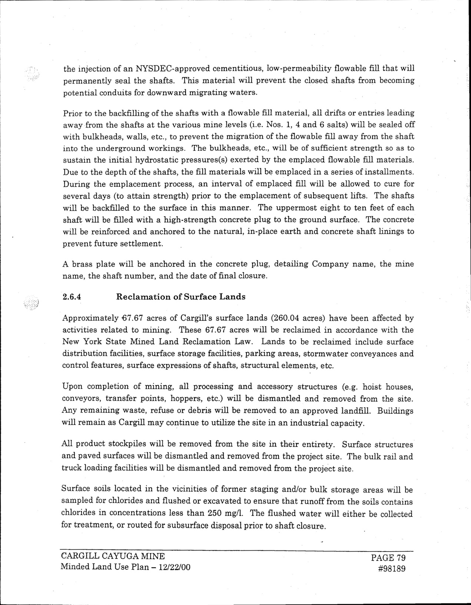
t h e i n j e c t i o n o f a n N YX D E C - a p p r o v e d c e m e n t i t i o u s , l o w - p e r m e a b i l i t y f l o w a b l e f i l l t h a t w i l l permanentlysealthe shafts This materialwillpreventthe closedshafts frombecoming potentialconduits for downwardmigratingwaters
Prior to the backfillingofthe shafts with a flowable fiUmaterial, alldrifts or entries leading awayfromthe shafts atthe various mine levels (i e Nos 1, 4and6salts)willhe sealedoff w i t h b u l k h e a d s , w a l l s , e t c , t o p r e v e n t t h e m i g r a t i o n o f t h e lf o w a b l e f i U a w a y f r o m t h e s h a f t
i n t o t h e u n d e r g r o u n d w o r k i n g s T h e b u l k h e a d s , e t c , w i l l h e o f s u f if c i e n t s t r e n g t h s o a s t o s u s t a i n t h e i n i t i a l h y d r o s t a t i c p r e s s u r e s ( s ) e x e r t e d b y t h e e m p l a c e d lf o w a b l e f i l l m a t e r i a l s D u e t o t h e d e p t h o f t h e s h a f t s , t h e if l l m a t e r i a l s w i l l b e e m p l a c e d m a s e r i e s o f i n s t a l l m e n t s Duringtheemplacementprocess, anintervalofemplacedfillwillheallowedtocurefor
Abrass plate willbe anchoredin the concrete plug, detailingCompanyname, the mine n a m e , t h e s h a f t n u m b e r , a n d t h e d a t e o f if n a l c l o s u r e
2. 6. 4 Reclamation of Surface Lands
'
A p p r o x i m a t e l y 6 7. 6 7 a c r e s o f C a r g i U s s u r f a c e l a n d s (2 6 0. 0 4 a c r e s ) h a v e b e e n a f f e c t e d b y
activities relatedto mining These 67.67acres willbe reclaimedin accordance withthe NewYorkState MinedLandReclamation Law Lands to he reclaimedinclude surface distribution facilities, surface storage facilities, parkingareas, stormwater conveyances and controlfeatures, surface expressions ofshafts, structuralelements, etc
L i p o n c o m p l e t i o n o f m i n i n g , a U p r o c e s s i n g a n d a c c e s s o r y s t r u c t u r e s (e g h o i s t h o u s e s , conveyors, transfer points, hoppers, etc)willhe dismantledandremovedfromthe site A n y r e m a i n i n g w a s t e , r e f u s e o r d e b r i s w i l l h e r e m o v e d t o a n a p p r o v e d l a n d if l l B u i l d i n g s willremainasCargiUmaycontinue toutUizethesiteinanindustrialcapacity
Allproductstockpiles willhe removedfromthe site in their entirety Surface structures andpavedsurfaceswillbedismantledandremovedfromtheprojectsite Thebulkrailand truckloadingfacilitieswillhe dismantledandremovedfromthe projectsite
Surface soilslocatedmthevicinities offormer stagingand/or hulkstorageareaswillhe sampledforchloridesandflushedorexcavatedtoensurethatrunofffromthesoilscontains c h l o r i d e s i n c o n c e n t r a t i o n s l e s s t h a n 2 5 0 m g / 1 T h e lf u s h e d w a t e r w U I e i t h e r h e c o U e c t e d for treatment, orroutedforsubsurfacedisposalpriortoshaftclosure
severaldays (toattainstrength)prior to the emplacementofsubsequentlifts
w i l l h e b a c k if l l e d t o t h e s u r f a c e i n t h i s m a n n e r T h e u p p e r m o s t e i g h t t o t e n
s h a f t w i l l h e if l l e d w i t h a h i g h - s t r e n g t h c o n c r e t e p l u g t o t h e g r o u n d s u r f a c e
willhe reinforcedandanchoredto the naturalin- place earthandconcrete shaftliningsto
,
preventfuturesettlement
CARGILL CAYXGA MINE MindedLandUsePlan- 12/22/00
PAGE79 #98189
The shafts f e e t o f e a c h T h e c o n c r e t e
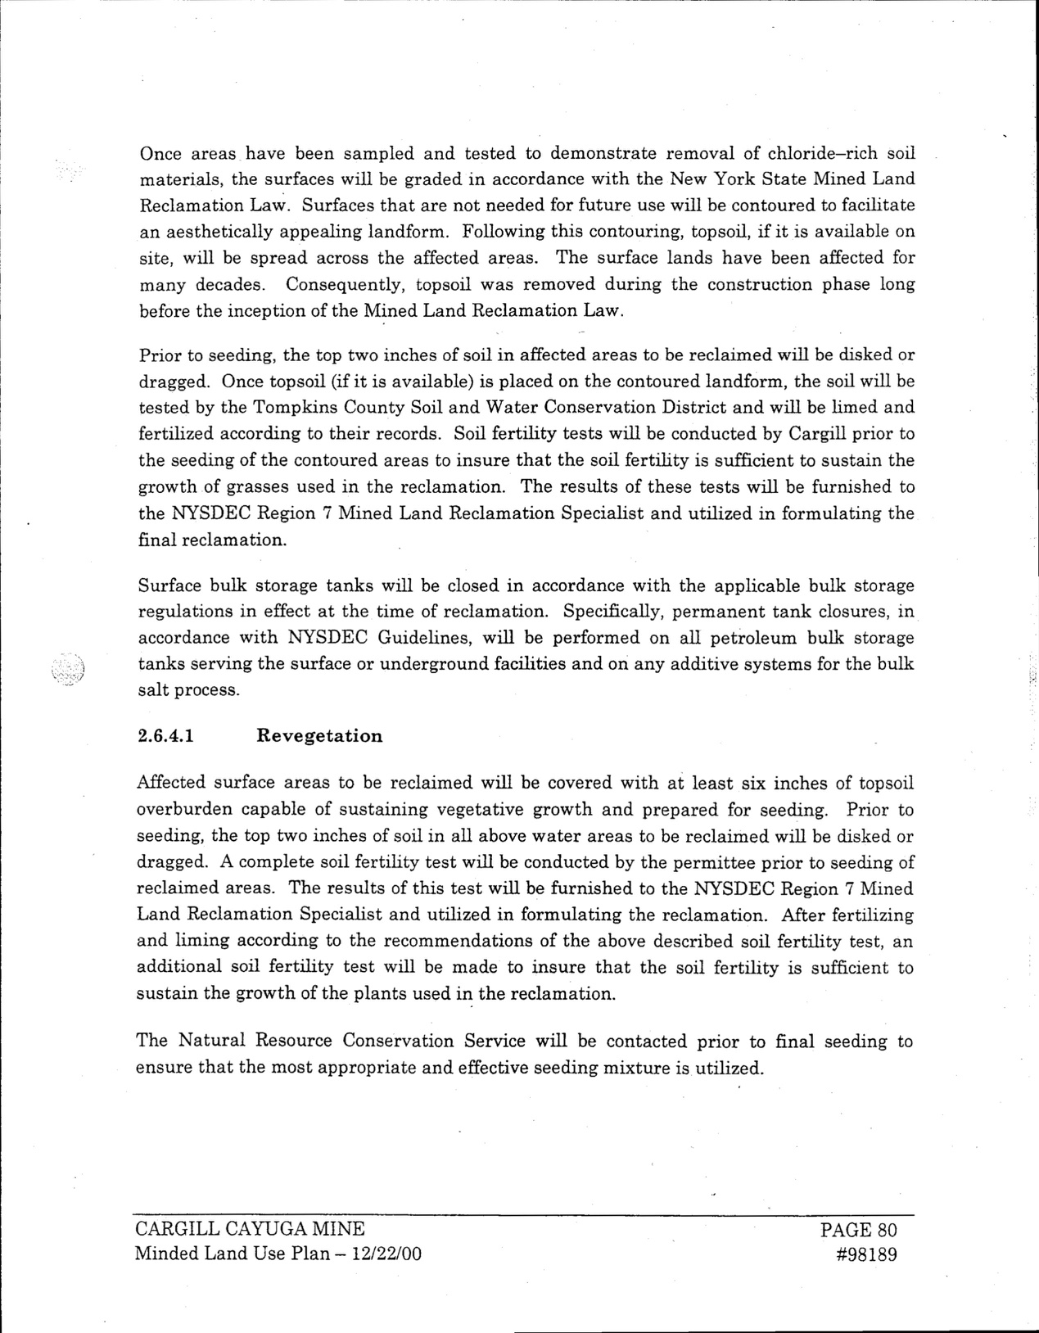
Once areas have been sampledandtestedto demonstrate removalofchloride—richsoil
M Reclamation Law Surfaces thatar e notneededfor future use willhe contouredto facilitate an aestheticallyappealinglandform Followingthis contouring, topsoil, ifitis available on site, willhe spreadacross the affectedareas The surface lands have been affectedfor manydecades Consequently, topsoilwas removedduringthe construction phase long
before the inception ofthe MinedLandReclamation Law
P r i o r t o s e e d i n g , t h e t o p t w o i n c h e s o f s o i l i n a ff e c t e d a r e a s t o h e r e c l a i m e d w i ll h e d i s k e d o r d r a g g e d O n c e t o p s o i l (i f i t i s a v a i l a b l e ) i s p l a c e d o n t h e c o n t o u r e d l a n d f o r m , t h e s o i l w i l l b e testedby the Tompkins CountySoilandWater Conservation Districtandwillbe limedand fertilizedaccordingto their records Soilfertilitytests willheconductedbyCargillprior to the seedingofthecontouredareastoinsurethatthesoilfertilityissufficienttosustain the growthofgrasses usedin the reclamation The results ofthese tests willhe furnishedto the NYXDECRegion 7MinedLandReclamation Specialist andutilizedmformulatingthe finalreclamation
Surfacehulkstoragetankswillheclosedinaccordancewiththeapplicablehulkstorage regulations meffectatthe time ofreclamation Specifically, permanenttankclosures, m
a c c o r d a n c e w i t h N YX D E C G u i d e l i n e s , w i l l h e p e r f o r m e d o n a l l p e t r o l e u m h u l k s t o r a g e tanksservingthesurfaceorundergroundfacilitiesandonanyadditivesystemsforthebulk salt pr ocess
2. 6. 4. 1 Revegetation
Affectedsurface areas tohe reclaimedwillhecoveredwithatleastsixinchesoftopsoil overburden capable ofsustainingvegetative growthandpreparedfor seeding Prior to seeding, the toptwo inches ofsoilmallabove water areas to be reclaimedwillbe diskedor draggedAcompletesoilfertilitytestwillheconductedbythepermitteepriortoseedingof reclaimedareas The results ofthis testwiUhe furnishedto the NYSDECRegion 7Mined LandReclamation Specialistandutilizedin formulatingthe reclamation After fertilizing andlimingaccordingto the recommendations ofthe above describedsoilfertilitytest, an a d d i t i o n a l s o i l f e r t i l i t y t e s t w i l l b e m a d e t o i n s u r e t h a t t h e s o i l f e r t i l i t y i s s u f if c i e n t t o sustainthegrowthoftheplantsusedinthereclamation
T h e N a t u r a l R e s o u r c e C o n s e r v a t i o n S e r v i c e w i l l h e c o n t a c t e d p r i o r t o if n a l s e e d i n g t o ensurethatthemostappropriateandeffectiveseedingmixtureisutilized
C-A. RGILL CAYXGA MINE PAGE 80 MmdedLandUse Plan - 12/22/00 #98189
materials
,
'
the surfaces willhe gradedmaccordance withthe New YorkState
inedLand
